|  |  |  |
| --- | --- | --- |
| **EXPERIMENT**  **NUMBER 3** | **GROUP 10** | Trần Minh Quân-19151078 |
| Surveying the electromagnetic interaction and re-testing Ampre’s law | **DATE** | 08/04/2022 |
| **LECTURER** | Tạ Đình Hiến |
| **REPORT DATE** |  |
| **GRADING** |  |

**Purpose:**

* About knowledge: State the measurement method and steps to conduct an experiment to investigate the magnetic interaction of lines electricity, Ampere's law of magnetic force.
* About skills: Proficiently using measuring tools, conducting experiments in the correct order to obtain data exactly.
* About attitude: Careful, persistent, accurate, honest, objective

1. **Thoeretical Basis**

A magnetic field is a special form of matter that occurs in space around moving charges. The existence of a magnetic field in a certain space is shown in that: any current, a moving charge or a magnet... placed in that space is subject to a magnetic force F. direction, the magnitude of the magnetic force F acting on an electric current placed in a magnetic field depends not only on the direction, direction, current strength, size, and shape of the conductor, but also on the characteristics of the magnetic field. Thus, it is possible to base on the force action of the magnetic field to give a characteristic quantity for the magnetic field in a certain space, regardless of the presence or absence of electric current, or moving charge... . in that space. That quantity is the magnetic induction vector B. The direction of the vector B at a defined point coincides with the direction of the test magnet needle placed at that point (going from the S pole to the N pole of the test magnet needle). .

In this experiment, we investigate the magnetic force F due to a uniform magnetic field acting on straight currents of different magnitude I and length l, placed in different directions in the magnetic field.

From the obtained results, re-verify Ampere's law of magnetic force and calculate the magnitude of the magnetic induction B of the given magnetic field.

1. **Formula used: $F=B.I.N.l.sin(α)$**
2. **Measurement instrument**

* Experimental tools include:
* Weigh the current.
* 0.1N dynamometer.
* The device generates a uniform magnetic field, size 70x90x40, using rare earth magnets, maximum 0.3T.
* The rotary stand has a 0-360°/1° protractor made of non-magnetic materials.
* Components box.
* A set of three wire frames of 100 turns, 0.3mm in diameter with a 4mm socket-type plug-in mechanism, size (80x60)mm; (80x40)mm; (80x20)mm.
* Multi-function clock showing number DT9205A.
* Illuminated fruit.
* The watch band has two plugs, 60cm long.
* The connection wire has two plugs, 800/0.75m long.
* 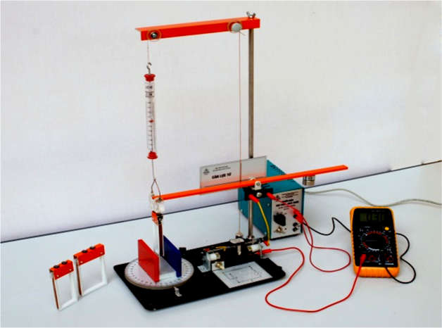Power supply voltage stabilizer 220V/0-12VDC3A continuously adjustable, with two clocks line and potential directives.

Figure : Measurement Instrument

**Investigate the magnetic force F depending on the current flowing in the frame**

b = 22.5mm, n = 100 rounds, α = ${90}^{o}$.

|  |  |  |  |
| --- | --- | --- | --- |
| I (A) | $F_{o}$ (mN) | $F^{'}$ (mN) | F= $F^{'}-F_{o}$ (mN) |
| 0.1 |  |  |  |
| 0.2 |  |  |  |
| 0.3 |  |  |  |
| 0.4 |  |  |  |
| 0.5 |  |  |  |

**Investigate the magnetic force F depending on the angle $α$ between I.L and B:**

I = (A), n= 100 rounds, b = 22,5 mm.

|  |  |  |  |
| --- | --- | --- | --- |
| $α$ (degree) | $F_{o}$ (mN) | $F^{'}$ (mN) | F= $F^{'}-F_{o}$ (mN) |
| 90 |  |  |  |
| 60 |  |  |  |
| 45 |  |  |  |
| 30 |  |  |  |
| 0 |  |  |  |

**Investigate the magnetic force F depending on the length of the current**

I= (A), n =100 rounds, α = ${90}^{o}$

|  |  |  |  |
| --- | --- | --- | --- |
| b (mm) | $F_{o}$ (mN) | $F^{'}$ (mN) | F= $F^{'}-F_{o}$ (mN) |
| 22.5 |  |  |  |
| 42.5 |  |  |  |
| 62.5 |  |  |  |

**Calculate the magnitude of $\vec{B}$ of the electrical field given:**

With α = ${90}^{o}$

|  |  |  |  |  |
| --- | --- | --- | --- | --- |
| I (A) | n (revolution) | l=b (m) | F (N) | $$k=\frac{F}{n.I.l}=B$$ |
| 0.1 | 100 | 0.0225 |  |  |
| 0.2 | 100 | 0.0225 |  |  |
| 0.3 | 100 | 0.0225 |  |  |
| 0.4 | 100 | 0.0225 |  |  |
| 0.5 | 100 | 0.0225 |  |  |
| Average | | | |  |